Application of risk management for IT-networks incorporating medical devices

(IEC 80001-2)
- This part of IEC 80001 creates a framework for the disclosure of security-related capabilities and risks necessary for managing the risk in connecting medical devices to IT-networks and for the security dialog that surrounds the IEC 80001-1 risk management of IT-network connection.
- It helps in identifying, developing, interpreting, updating and maintaining security cases for networked medical devices.
- The capability descriptions in this report are intended to supply:
  - Health delivery organizations (HDOs)
  - medical device manufacturers (MDMs)
  - IT vendors
- This security report presents an informative set of common, high-level security-related capabilities useful in understanding the user needs, the type of security controls to be considered and the risks that lead to the controls.
- This document leverages the requirements set out in ISO/IEC 15026-2 for the development of assurance cases.
- It is not intended that this security case framework will replace a risk management strategy, rather, the intention is to complement risk management and in turn provide a greater level of assurance for a medical device by:

- Mapping specific risk management steps to each of the IEC TR 80001-2-2 security capabilities.
- Identifying associated threats and vulnerabilities and presenting them in the format of a security case with the inclusion of a re-useable security pattern.
- Providing guidance for the selection of appropriate security controls to establish security capabilities and presenting them as part of the security case pattern.
- Providing evidence to support the implementation of a security control, hence providing confidence in the establishment of each of the security capabilities.

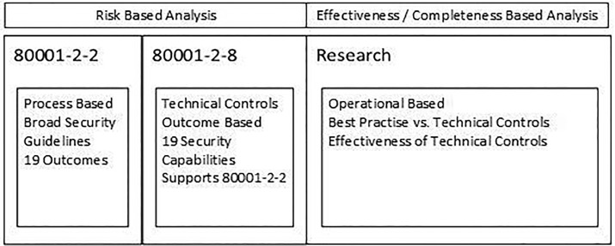
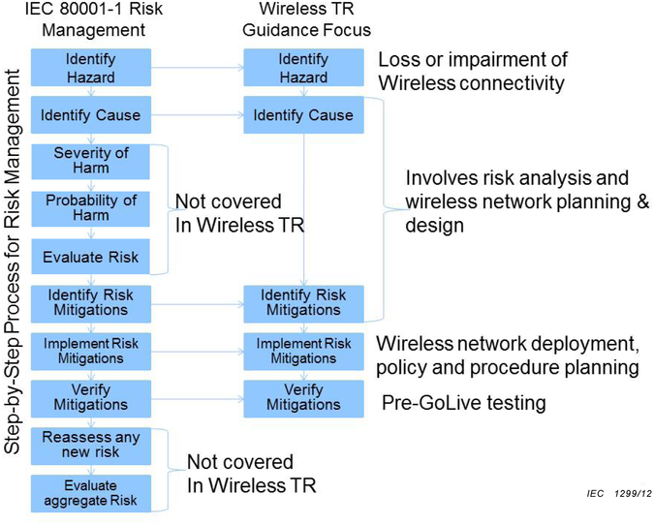

REFERENCES
https://www.iso.org/obp/ui/#iso:std:iec:tr:80001:-2-2:ed-1:v1:en
https://www.sciencedirect.com/science/article/abs/pii/S0920548917302313
https://www.iso.org/standard/69355.html
https://www.accessdata.fda.gov/scripts/cdrh/cfdocs/cfStandards/detail.cfm?standard__identification_no=36409

